Sentimental Analysis for Marketing

Phase-4

***We further building our project by loading the Data Set and Describing that and Cleaning the data and Visualising the distributions and Evaluation in Google colab Notebook.***

### **Let’s Import the necessary Modules and take a look at the data:**

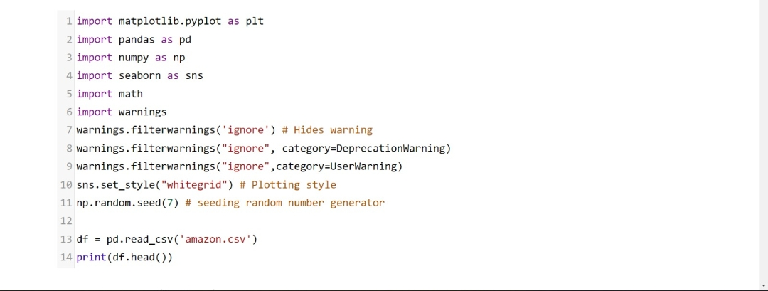

**Describing the Dataset:**

*Overall description about the dataset should be contain in this*

The purpose of this to done a overall relationship between the data and the future predictions based upon that.

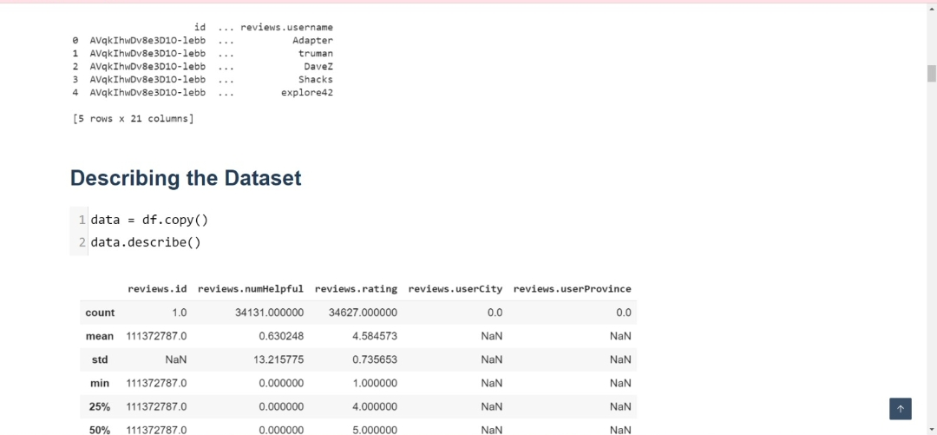

**We need to clean up the name column by referencing asins (unique products) since we have 7000 missing values:**

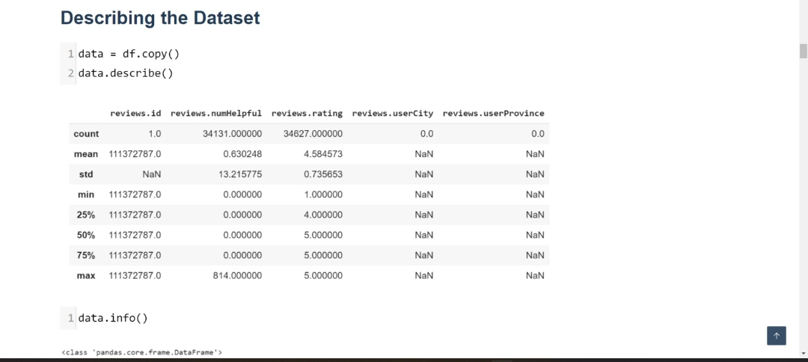

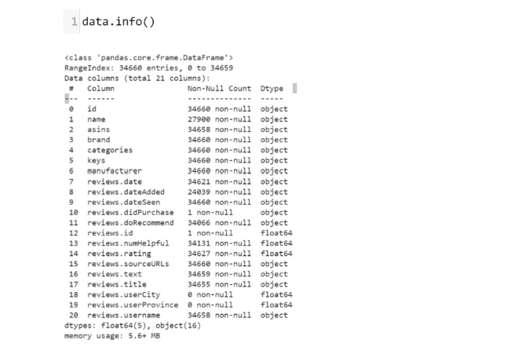

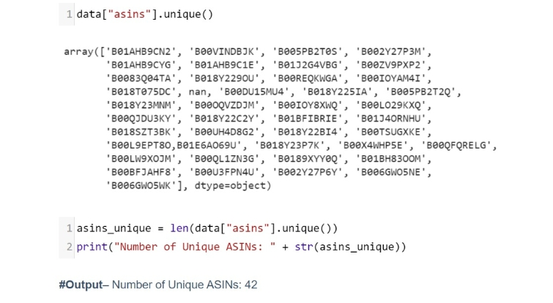

**Visualizing the distributions of numerical variables:**

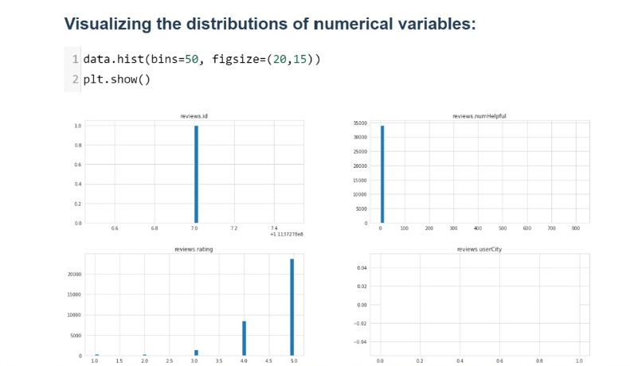

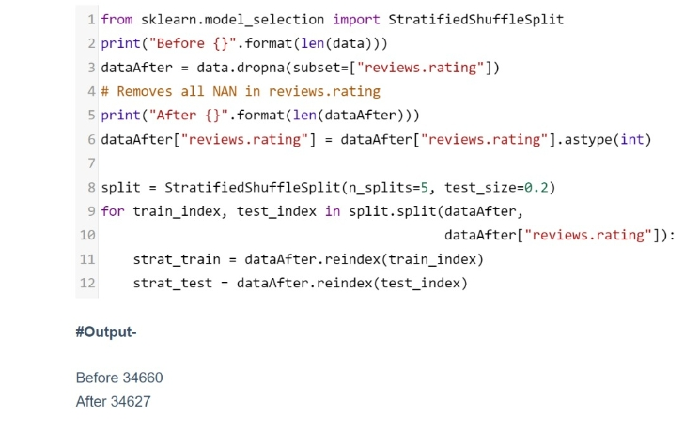

**Outliers in this case are valuable, so we may want to weight reviews that had more than 50+ people who find them helpful.**

**Majority of examples were rated highly (looking at rating distribution). There is twice amount of 5 star ratings than the others ratings combined.**

**Split the data into Train and Test:**

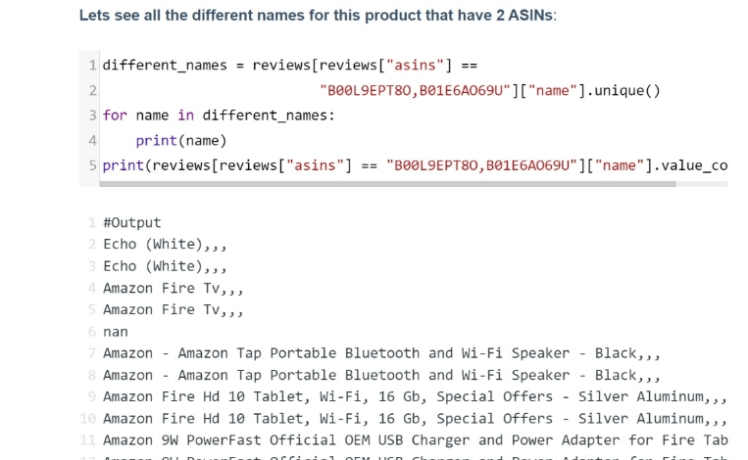

**Data Exploration (Training Set):**

***We will use regular expressions to clean out any unfavorable characters in the dataset, and then preview what the data looks like after cleaning.***

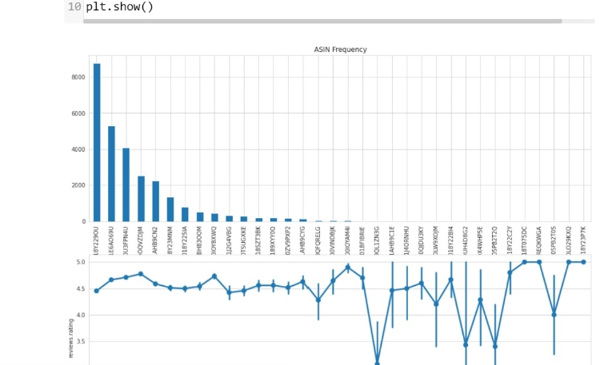

***Sentimental Analysis:***

Using the features in place, we will build a classifier that can determine a review’s sentiment.

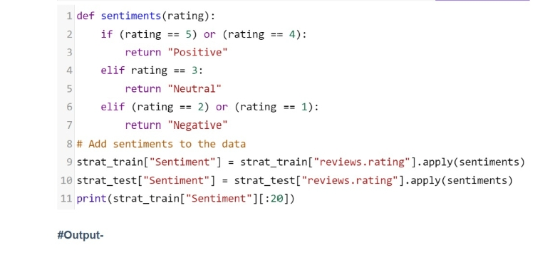

**Output:**

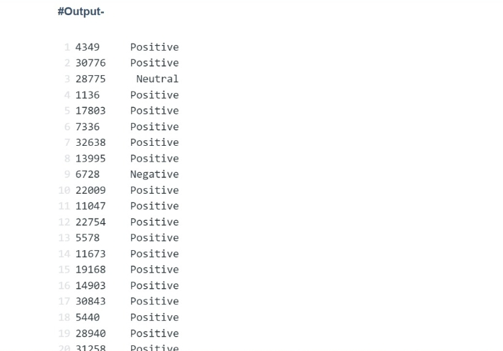

**Team Members**

**I.JaharaAsmi**

**M.Muthulakshmi**

**K.Sandhiya**

**M.Shajitha Barveen**

**M.SathiyaJothi**

**JP College Of Engineering**